|  |  |
| --- | --- |
| **Date** | **5th November 2022** |
| **Team ID** | **PNT2022TMID28767** |
| **Project Name** | **IoT Enabled Smart Farming Application** |



**Develop A Mobile Application**

**IoT Enabled Smart Farming Using Android Phone**

Proposed System

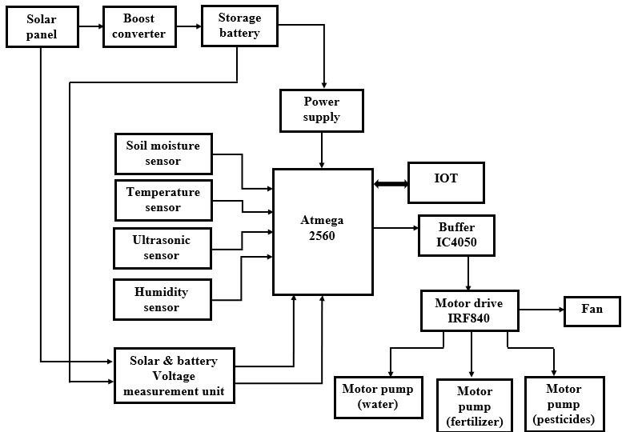

**Fig. 1**: Block Diagram of Proposed System

|  |  |
| --- | --- |
| The purpose of this project is to help the user to monitor and control the farm located anywhere, with the help of Internet of Things. The user has access to the location using an IoT Screen specifically designed for that farm. Solar Power that is stored in a Battery serves as Power Source for the Circuit located in the farm. Solar Power used in here is controlled using MPPT. The user can monitor and control the below features of the greenhouse located anywhere using the Smart Phone.   * Soil Moisture Content and irrigate the plants * Temperature to be maintained with the help of Fan for Cooling purpose * Humidity to be maintained with the help of Water Sprayer with Fan * Height of the plant when it is ready for Harvest | **IoT Screen in Mobile Phone**  The below page is designed using PHP Programming. The user has to open the below link in Mobile Browser Window.IoTPage:http://iotproject2019.000webhostapp.co m/irrigation%20iot/  The user can monitor the Values of Soil Moisture, Temperature, Humidity and Plant  Height and control using the button provided to control the values using the Buttons (Fan, Pump). The user can also add fertilizer & Pesticide to the plant by clicking  “Fertilizer” & “Pesticide” Button. Harvest Status will be updated as “Ready for Harvest” when the plant reaches the threshold height. All the threshold values for monitoring the plant can be updated manually in the below screen. |

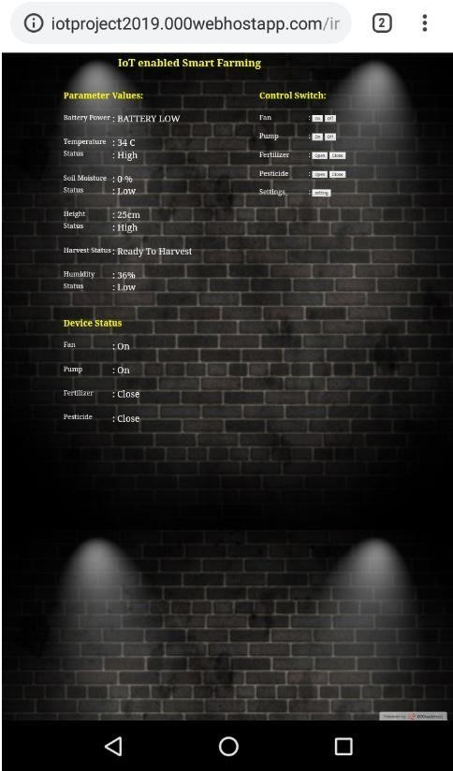

**Fig 2:** IoT Screen 1

By the clicking on the “Settings” page in the above screen Soil Moisture, Humidity and Plant Height for Harvest. The it will get directed to the below screen. User can manually minimum and maximum values will be termed as “Low” set the minimum and maximum values of Temperature, and “High” in the screen under “Parameter Values”.

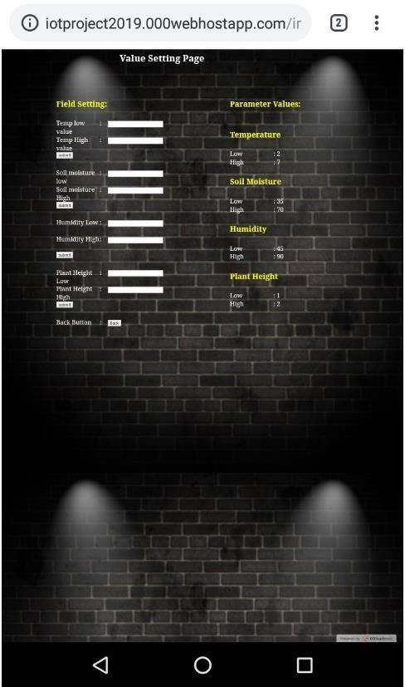

**Fig. 3:** IoT Screen 2

The user has to open the Browser Window in Mobile and enter the below IoT Page link. Also, the kit should always The below screen will appear at first. User can login using be connected to Power Supply 24/7.Once the user opens the Mobile or Computer. IoT below link in Mobile Browser Window. IoT Page:

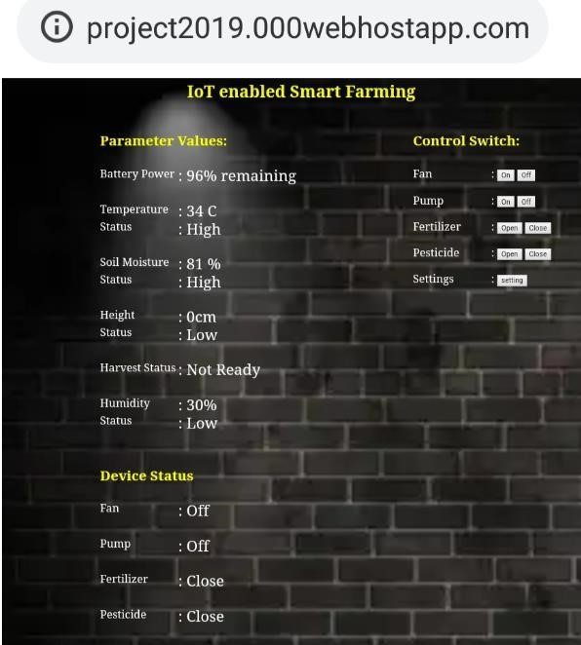

**Fig. 4:** Home Screen – IoT

This system can be modified for any type of individual Smart Farming based on the Crop Type. Hence user can click on “Setting” Icon. Based in the Crop Type, user enters the threshold values (Maximum and Minimum) for Temperature, Soil Moisture, Humidity, and Plant Height. Click on the Submit Button after entering the values. The values will be uploaded to Internet and it is received by the controller in the kit that is located remotely.

Along with the data sent to the controller, real time update happens in IoT Screen and also the LED Screen in the Kit. It takes around 20 – 25 seconds for the data to get updated from IoT Screen to the Controller in the Hardware Kit. The Hardware Kit used a 5 V Rechargeable Battery which is charged using Solar Power. This Solar Power is controlled using MPPT Algorithm. Airtel Sim Card is used for Internet Purpose in the Hardware Kit. Once the hardware kit is switched on, we have to ensure that Signal Strength is good, which you can identify from the blinks

(Blue Color).The faster the blinks, signal strength is good. Solar Panel gives an output of nearly 15 V. Battery Capacity also can be monitored in the IoT Screen.

|  |
| --- |
| **Fig. 5:** Value Setting Page |

## Conclusion

Solar Power is along with Battery Storage is used as Power

Supply to operate the circuit. It is incorporated with Boost Converter. The sensor in farming location provide information on the Soil Moisture, Temperature, Humidity and Height of the Plant. Fan and Motor Pumps (Water, Fertilizer & Pesticide) are connected to Motor Drive. The above-mentioned data and the Motor Drive can be monitored and controlled from IoT Page in Android Phone. The monitoring values can be changed manually, based on the type of plants to be monitored. This system is sourced by Solar Panel and controlled by MPPT Algorithm.

## Future Scope

Also known as precision agriculture, precision farming can be thought of as anything that makes the farming practice more controlled and accurate when it comes to raising livestock and growing of crops. In this approach of farm management, a key component is the use of IT and various items like sensors, control systems, robotics, autonomous vehicles, automated hardware, variable rate technology, and so on. The adoption of access to high-speed internet, mobile devices, and reliable, low-cost satellites (for imagery and positioning) are few key technologies characterizing the precision agriculture trend. Precision agriculture is one of the most famous applications of IoT in the agricultural sector and numerous organizations are leveraging this technique around the world. Drones are being used in agriculture in order to enhance various agricultural practices. The major benefits of using drones include crop health imaging, integrated GIS mapping, ease of use, saves time, and the potential to increase yields. With strategy and planning based on real-time data collection and processing, the drone technology will give a high-tech makeover to the agriculture industry.

## References

1. Andreas Kamilaris, Feng Gao, Francesc X, Muhammad Intizar Ali and PrenafetaBoldu (2016), ‘Agri-IoT: A semantic framework for Internet of

Things-enabled smart farming applications’, IEEE 3rd

World Forum on Internet of Things (WFIoT)

1. Anupama Hongal, Jyothi and Prathibha (2017), ‘IOT Based Monitoring System in Smart Agriculture’, International Conference on Recent Advances in Electronics and Communication Technology (ICRAECT)
2. Dhanashri H. Gawali and Shweta B. Saraf (2017), ‘IoT based smart irrigation monitoring and controlling system’, 2nd IEEE International Conference on Recent Trends in Electronics, Information & Communication Technology (RTEICT)
3. Kale and Patil (2016), ‘A model for smart agriculture using IoT, International Conference on Global Trends in Signal Processing’ Information Computing and Communication (ICGTSPICC)
4. Rob Dolci (2017), ‘IoT Solutions for Precision Farming and Food Manufacturing: Artificial

Intelligence Applications in Digital Food’, IEEE 41st Annual Computer Software and Applications

Conference (COMPSAC)